The Arc of Massachusetts
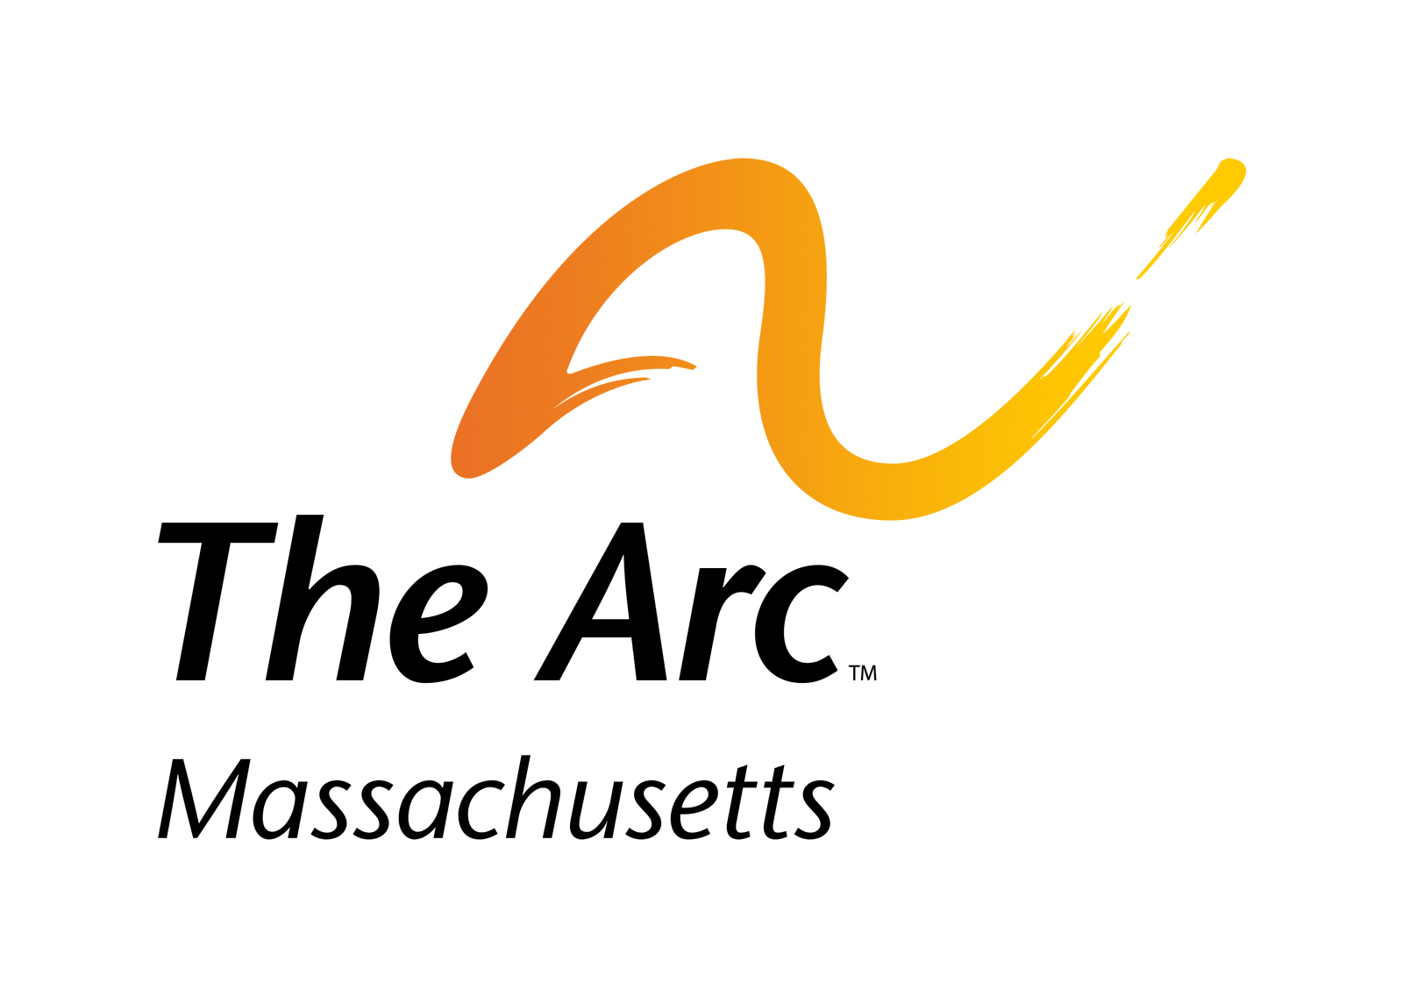

The Yale School of Nursing
Operation House Call Program

Student Profile Form

[PHOTO OF STUDENT HERE]

Name:

YSN Student Email (important: please give YSN email):

Have you ever had any prior experience or a relationship with anyone with an intellectual or developmental disability? If so, please elaborate.

Please list your hobbies and interests.

Do you have any food or pet allergies or dietary restrictions? If so, please list:

Please list any personal information about yourself that you wish to share with the Operation House Call Parent Instructor, and host family. This profile is shared with your assigned home visit family.

