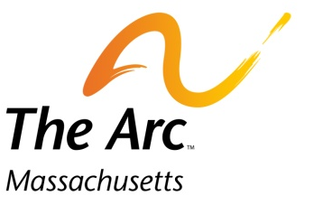
Operation House Call

Families teaching health professionals
217 South St. Waltham, MA 02453 • 781-891-6270 • www.arcmass.org • arcmass@arcmass.org

Yale School of Nursing Operation House Call
Parent feedback/evaluation

Name of the Student: Date:
Key 4= Excellent 3=very good 2=Average 1=Concern/Worry NA= Not Applicable

Communication skills
- Listens well 4 3 2 1 NA

- Uses open ended questions asked sensitively 4 3 2 1 NA

- Pays attention to my issues (has good eye contact) 4 3 2 1 NA

- Encourages me (parent) to discuss my issues 4 3 2 1 NA

- Tries to connects with the child 4 3 2 1 NA

- If communication with a child challenging, asks
parent(s) for suggestions 4 3 2 1 NA
- Communicates and interacts with sibs 4 3 2 1 NA

- Able to respond to emotions with empathy 4 3 2 1 NA

- Uses people first *** language 4 3 2 1 NA

- Does not use medical jargon 4 3 2 1 NA

Attitude
- Respectful of parental knowledge and judgment 4 3 2 1 NA

- Respectful of the culture and values of the family 4 3 2 1 NA

- Expresses optimism and displays a positive attitude 4 3 2 1 NA
toward the child’s life

- Responds appropriately to the siblings 4 3 2 1 NA

- Sensitive to and addresses parents and child(ren)
in the context of the family 4 3 2 1 NA
- Curious about and wishes to listen to and understand
the family experience 4 3 2 1 NA

Other comments:

Strengths:

Areas needing improvement:

*** People first = A “child with autism” rather than an autistic child. Or a child with Down syndrome etc.

