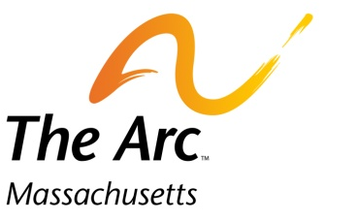
Operation House Call

Families teaching health professionals
217 South St. Waltham, MA 02453 • 781-891-6270 • www.arcmass.org • arcmass@arcmass.org

Yale School of Nursing Operation House Call Program 2018
Program Coordinator: Susanna Peyton peyton@arcmass.org cell:781-929-9917
Family Coordinator: Carolyn Cappiello cappiello@arcmass.org

Family Volunteer Information Form

Date:
Name:
Address:
City, State, Zip:
Best time and place to reach you? (for example: email 1st? home tel or cell: 2nd?):

Home: Cell:
Work: Email:

Child/children: (please list names and dates of birth of all children):

What is the nature of your child’s special need(s)? Please be specific (e.g. autism, verbal/non-verbal, seizure disorder, important medical issues, etc.) and identify child by name for clarity:

Please comment briefly on schooling, social or recreational interests of child(ren):

Is there anyone else, not specified above, who lives in the home (other family members, care providers, etc.)?

Do you have pets?

Allergies?

Confidential, for Operation House Call use only

