Operation House Call
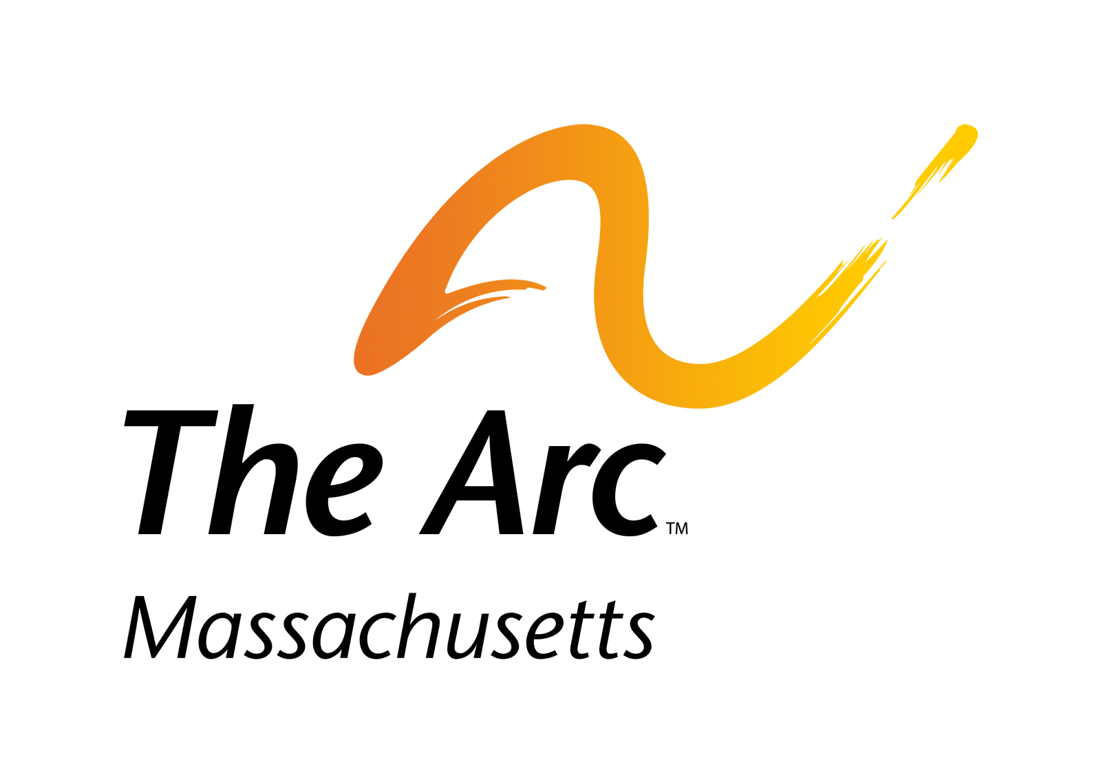

Families teaching health professionals

Operation House Call Student Profile Form:

Photo:

Name:

Email (please provide school email):

Do you have access to a car for one-time host family visit?

Language fluency, list language(s):

Have you ever had any prior experience or a relationship with anyone with a disability? If so, please elaborate briefly:

Please list your hobbies and interests:

Do you have any food allergies or dietary restrictions? If so please list:

Please list any personal information about yourself that you wish to share:

