Login Troubles on Operation House Call school sites

Sometimes a student has trouble logging in. This is typically because their password is incorrect. The steps outlined in this document will show you, the admin, how to remedy this and get the student on their way to completing their course work and interact with the rest of their class.

1. Log into the OHC site for that student's school in your web browser.

2. Scroll down a bit and you should see the Site Administration box on the left:
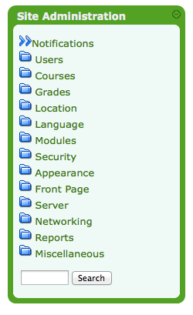

3. Click the Users link, which will expand to show some sub-navigation:

4. Click Accounts to expand further sub-navigation:
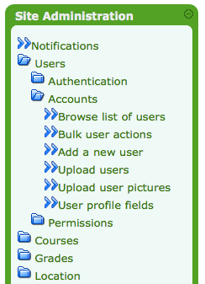

5. Click the Browse list of users link to navigate to the accounts page:
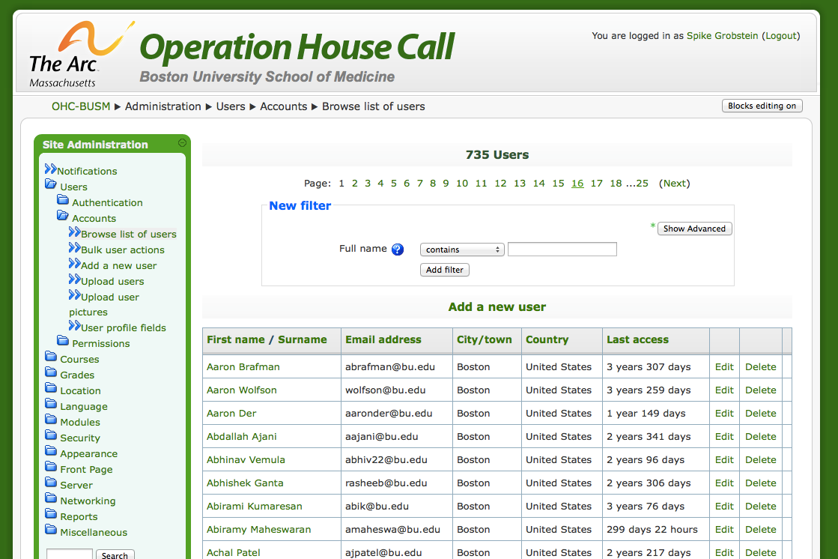
From here, you can perform a search to locate the student's user account. You can search based on their first and/or last name in the text field provided or you can click Show Advanced to perform a more granular search (eg searching on their email address).

6. After performing a search, you should see a result page that looks like the following:
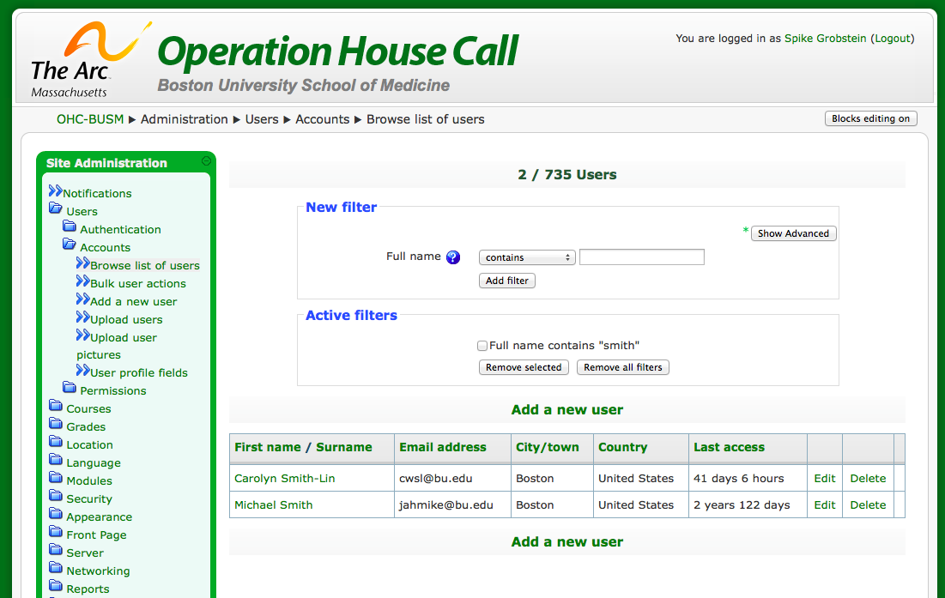
7. Locate the student that's having trouble and click the Edit link on their row. This will take you to a form to edit their account:
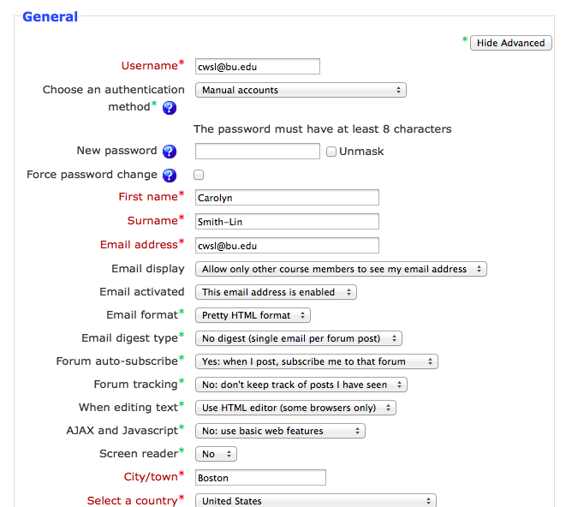

8. Verify that the username that they're logging in as is correct. They should confirm that for you and it should match the Username field exactly (it is case-sensitive).

9. Change the password field. You can check the Unmask checkbox to have it be visible, rather than masked by bullets. You should be able to copy this to paste into an email for them.

10. Check the Force password change checkbox. When the student logs in with the new password, this will present them with a form to change their password to something more personal and memorable to them.

11. Click the Update Profile button at the bottom of the page to save the new password.

12. Notify the student of the changed password and have them try to log in again. Be sure to include their username and the URL for the school's OHC site as well, to ensure that they're doing everything correctly.

