Operation House Call
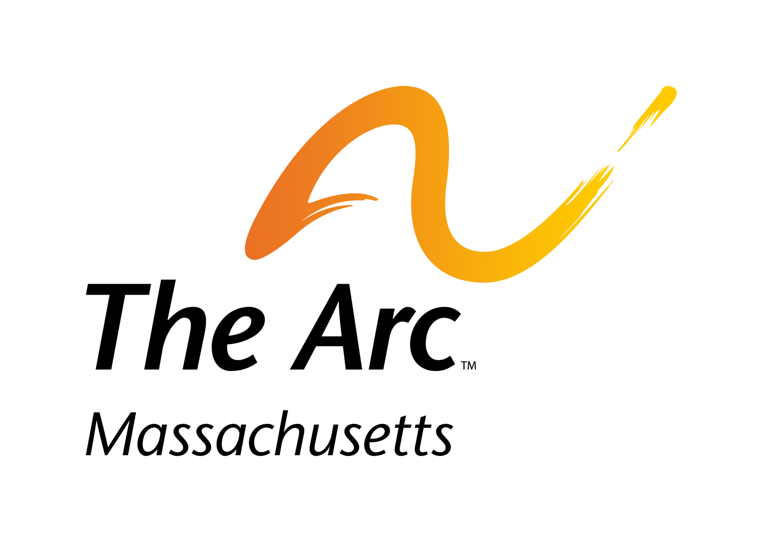

Families teaching health professionals

From time to time it is helpful for The Arc to use quotes from students who have taken this course in order to support the goals of education for health care practitioners.

Please consider giving us the following permission:

I allow The Arc of Massachusetts to quote comments from my training as long as there is no identifying information either about my host family or myself in the quote:

Name Signature Date

