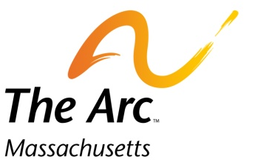
Operation House Call

Families teaching health professionals
217 South St. Waltham, MA 02453 • 781-891-6270 • www.arcmass.org • arcmass@arcmass.org

Robyn Dollar, Family Coordinator
dollar@arcmass.org
617-388-2631

Family Volunteer Information Form

Date:
Name:
Address:
City, State, Zip:
Best time and place to reach you? (ex: email 1st? home tel: 2nd?):

Home: Cell:
Work: Email:

Child/children: (please list names and dates of birth):

What is the nature of your child’s, or childrens’, special need(s)? Please be specific (e.g. autism, verbal/non-verbal, seizure disorder, important medical issues, etc.) and identify child by name for clarity:

Please comment briefly on schooling, social or recreational interests of child(ren):

Is there anyone else, not specified above, who lives in the home (other family members, care providers, etc.)?

How many times would you like volunteer annually (1-6)?

Are you interested in volunteering on short notice if another family needs to cancel?

Pets?

Allergies?

