THE BOSTON GLOBE
Seeking grown-up care
MDs' unease found to leave many disabled adults with pediatricians
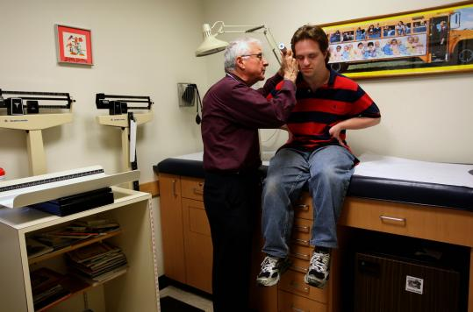
Dr. Dan Palant, a pediatrician in Lexington, still treats longtime patient Shalom Lowell, who is 26 and has Down syndrome. (Globe Staff Photo / Joanne Rathe)
By Patricia Wen
Globe Staff / February 2, 2009
LEXINGTON - One day last week, Dr. Daniel Palant walked into his pediatric clinic, decorated with Mickey Mouse posters and antique baby bottles. He was prepared to see his next patient, whom he has known since birth: Shalom Lowell, who has Down syndrome. Palant loves meeting the same patients year after year, but he thinks that sometime soon this one should see a new doctor.
Lowell is now 26 years old and his body stretches well beyond the length of the examining table.
"It's best for him to see an internist," said Palant, after examining the young man, who has had recent bouts of fatigue. "He shouldn't be part of a pediatric practice."
The incidence of adult disabled patients staying with their pediatricians long after their 18th birthday is one of many issues raised in a report released today by The Arc of Massachusetts, an advocacy group for people with intellectual and developmental disabilities.
The study, "Left Out in the Cold: Health Care Experiences of Adults with Intellectual and Developmental Disabilities in Massachusetts," found that many disabled adults face longer waits than most people finding good internists, and that prevents them from getting the best care for common adult conditions such as hypertension, heart disease, or thyroid disorders.
The report found that, among other reasons, many internists avoid disabled patients because of uneasiness with them.
Also, many doctors feel that insurers do not pay enough to compensate them for the longer time it often takes to listen to - and care for - these patients.
Leo Sarkissian, executive director of Arc, acknowledged that many disabled adults pose special challenges during routine visits.
Some talk slowly or unclearly about what ails them, and others panic at being touched, even needing to be restrained for a routine throat culture or ear exam.
Some disabled adults may have physical limitations in simply getting up to the examining table.
"Doctors avoid them," Sarkissian said.
Della Jones, a Brockton mother, said her 18-year-old daughter, who has autism, will often "scream and push" during exams because of fears over the procedures, and Jones believes that is partly why she has yet to secure a good primary care doctor.
As a result, many pediatricians, who typically have more training involving disabilities, see their patients well into adulthood - some as old as 40, said Mandy Nichols, director of healthcare policy for Arc.
The report included interviews with more than 100 adults with disabilities, their parents or guardians, and community support professionals.
Two dozen physicians and other healthcare clinicians also took part in the study, funded by the Boston Foundation.
Nichols said there are no available statistics showing how many of the state's 180,000 disabled citizens see pediatricians as adults.
The report recommends that the state call for added training for doctors to become more sensitive to the needs of disabled adults.
Sarkissian said many doctors, if given the choice, talk directly to a parent or guardian about a disabled adult's medical problems, even when the disabled patient is in the examining room and able to understand. The report also calls for the state to increase insurance reimbursements to doctors who see adult patients with disabilities, accounting for the extra time and training.
Palant said he has long taken an interest in serving the disabled population because his older sister is developmentally disabled, and he has helped oversee her care for years. His pediatric practice has about a dozen adult patients with disabilities.
On Thursday, Palant listened as Lowell explained haltingly, but clearly, that he will often "fall asleep right after work," something that didn't happen before.
After Palant questioned Lowell about his sleeping and eating habits, the patient admitted that he sometimes has an erratic meal schedule and goes to bed late while living in his group home.
He vowed to get on a better schedule to boost his energy.
The session, which included a physical exam that prompted Lowell at times to break into fits of giggles, lasted about an hour.
Asked how much longer he plans to see Lowell, the pediatrician said he feels tremendous loyalty to the young man and his family.
"I play it by ear," he said.
Patricia Wen can be reached at wen@globe.com
______________________________________

